Question 1:
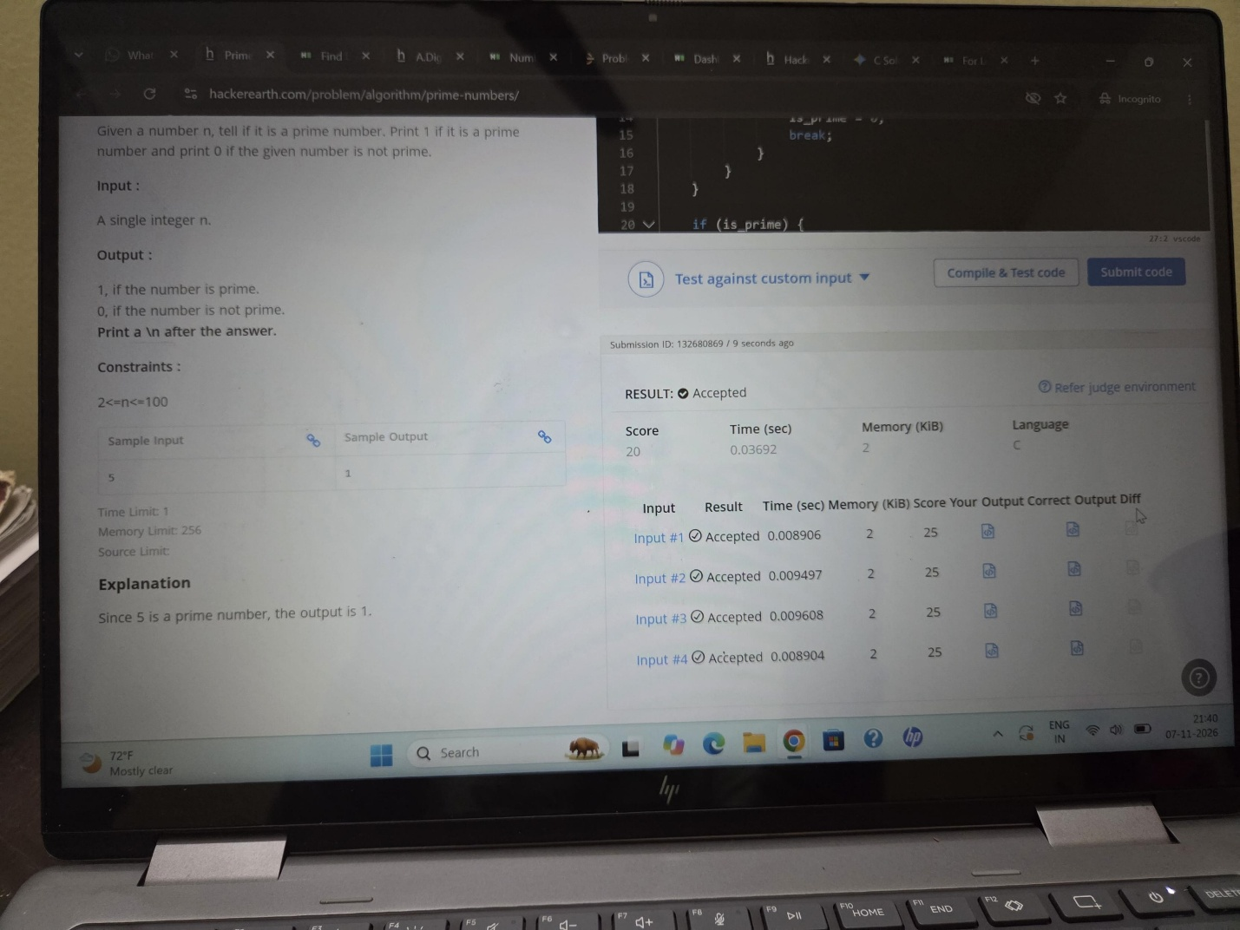
https://www.hackerearth.com/practice/basic-programming/input-output/basics-of-input-output/practice-problems/algorithm/io-exercise/
Question 2:
https://www.hackerrank.com/challenges/solve-me-first/problem
Question 3
https://leetcode.com/problems/add-two-integers/submissions/2191356349/
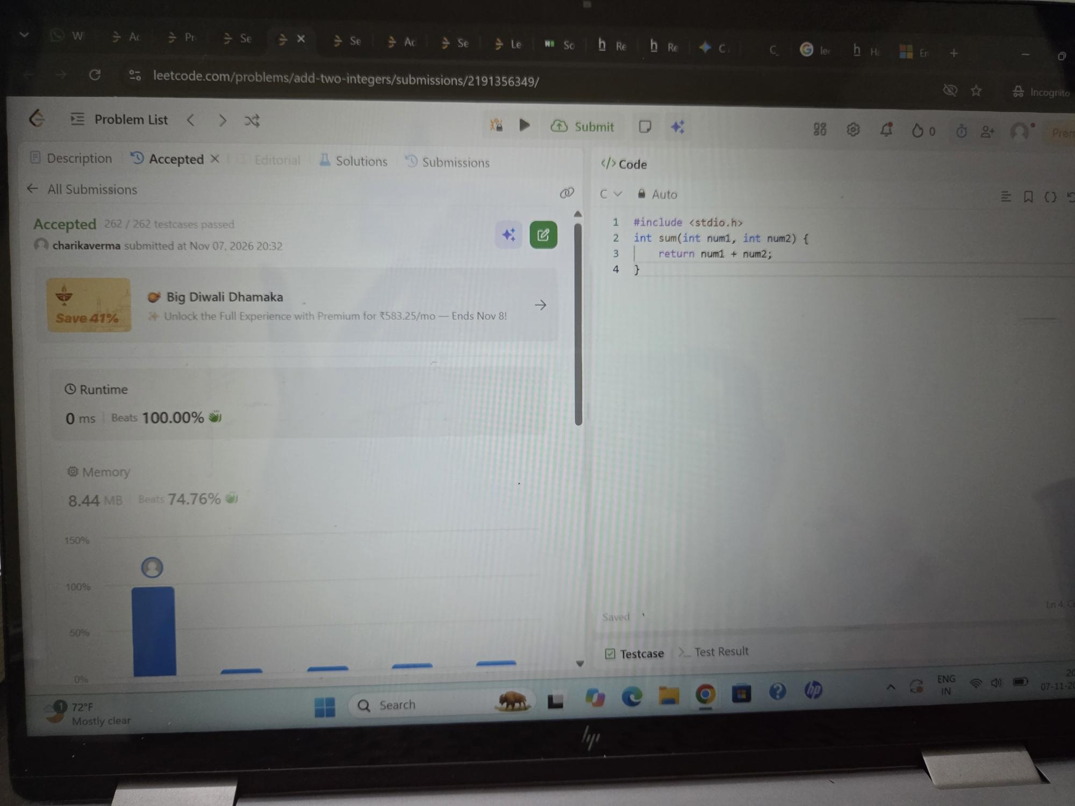

Question 4 :

https://leetcode.com/problems/calculate-delayed-arrival-time/submissions/2191359538/
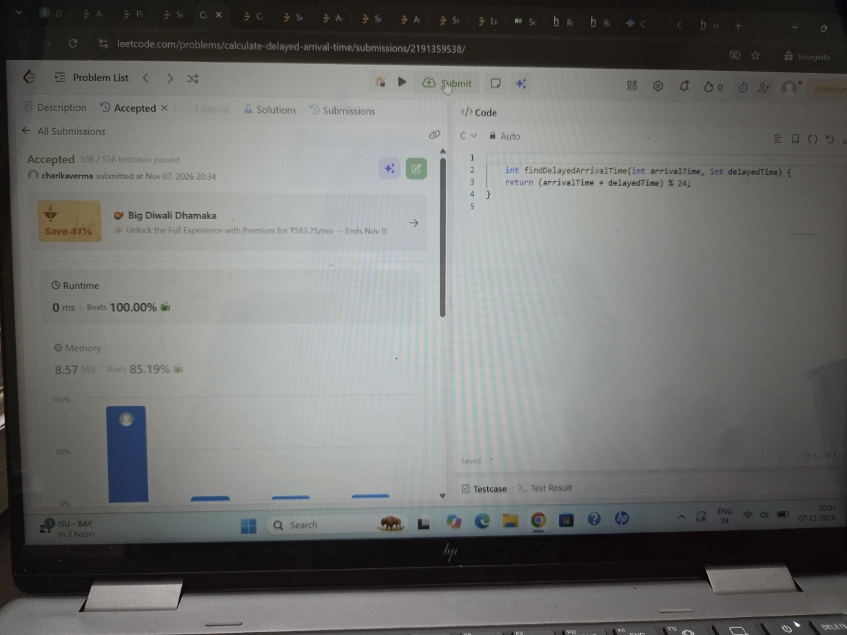

Question 5:
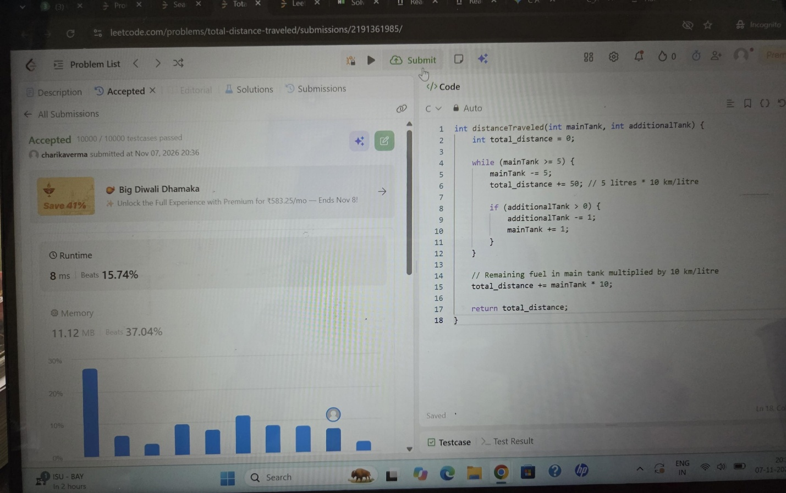
https://leetcode.com/problems/total-distance-traveled/submissions/2191361985/

